**Summary:**

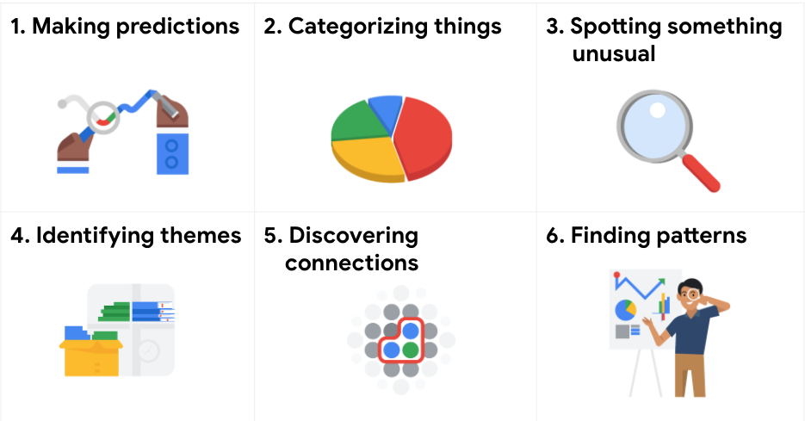

### **Making predictions :** Using data to make an informed decision about how things may be in the future.

### **Categorizing things :** Assigning information to different groups or clusters based on common features.

### **Spotting something unusual :** Identifying data that is different from the norm.

### **Identifying themes :** Grouping categorized information into broad concepts.

### **Discovering connections :** Finding similar challenges faced by different entities and combining data and insights to address them.

### **Finding patterns :** Using historical data to understand what happened in the past and therefore likely to happen in the future again.

A data analyst identifies and classifies keywords from customer reviews to improve customer satisfaction. This is an example of which problem type : **Categorizing things**

The spotting something unusual problem type could involve which of the following scenarios : **A data analyst working for an agricultural company examines why a dataset has a surprising and rare data point**

A data analyst at an online retailer works with historical sales data. The analyst identifies repeating trends in the sales data. This is an example of which problem type : **Finding patterns**